ICT Engineering

4th Semester

15/05/2019

**Table of content**

Contents

1 Introduction 3

2 Group Description 4

3 Considerations before the project 6

4 Project Initiation 8

4.1 Risk Assessment 9

4.2 Version Control and File Management 10

5 Project Description 13

6 Project Execution 14

Sprint 1 15

Sprint 2 16

Sprint 3 18

Sprint 4 20

Sprint 5 21

7 Personal Reflections 22

8 Conclusion 23

# Introduction

# Group Description

**Ionut-Cristinel Putinica**

I consider myself as an open-minded person that is always open to suggestions and any kind of feedback, because I am fully aware that there are still a lot of things and concepts that I need to learn about, and I consider that criticism is the best way to better yourself. Most of the times, when I want to do something, if I consider that something as being something important for my personal development, I will fully commit myself to the task, usually spending as much time as needed to get to a result that is as good as it can be, and I consider this as being both a quality and a defect, because a lot of times I spend too much on details just to perfect them. I am more of a group-work person, because, when I do something, I usually want the feedback from at least another person as well, just so I can make sure that the product of my work is one of high-quality.

**Erika Szasz**

I am always enthusiastic when it comes to facing new challenges that help me grow. I would describe myself as someone who is positive, perfectionist and a self-driven individual. I like everything to be organized and for that reason, at times, I find it challenging to work in a team because not everyone has the same definition of how to do things as I do. Nevertheless, I acknowledge my weaknesses and I always try to actively overcome them. For that reason, I see every semester project to be a perfect opportunity to develop and learn new things about myself and others. I think it is important to accept feedback from others, as constructive criticism is a good way to see yourself through the eyes of other people and understand what can be improved about the way you present and do things.

# Considerations before the project

**Ionut-Cristinel Putinica**

I am going into SEP4 with a small dose of pendency, the reason for this being the hefty amount of new tasks, but also the scale of the project that my group has to develop. My main goal is to fully dedicate myself on the work related to the project, until the point that me and the other members of the group consider that our expectations regarding the final product that we have in mind will be met. I am certain that the work process will be full of challenges and problems, due to all the new things that we will have to implement, but I am looking forward to all of them, since I find that solving a problem, “getting your hands dirty”, is the best way to learn something new.

**Erika Szasz**

SEP3 was a big challenge for me as I had just transferred from Mechanical Engineering and was new to the world of Software Engineering. But that experience thought me a lot and made me eager to see what SEP4 was all about. Admittingly, at first it seemed a bit overwhelming from all points a few. It seemed to be a very complex project that requires a large amount of specialized knowledge and dealing with a team of 10 people also presented itself to be a challenge. My goal at the beginning of the semester was to absorb as much information as I can about the technologies we would have to use and do my best regarding my part in the group.

**Angel Petrov**

As far as I can see, we are going to work in a different structure this semester. My previous experience was working in 4 man groups. I like the fact that the teachers are trying to test us in every possible way. This prepares an individual for real life challenges after they finish with university. The disadvantages to such a massive team would be coordination and communication. Teams would need to collaborate at certain times between each other so that they are able to create a final working product as well as meet. Again, communication is key and with the right set of coordination, unity will make strength in the group.

# Project Initiation

**Personal events**

Personal affairs can differ from person to person inside the group, taking into consideration the fact that the group consists of ten members, which leads to a very high probability of personal events emerging as a problem. Job calls, extracurricular activities, travelling and a lot of other factors can interrupt or delay a meeting or an assigned task. Eight out of ten members are not from Denmark, thus, the workflow of the team can slow down during the holiday periods, as a direct aftereffect of travelling. Exams, family and spouses also have a high chance of delaying the work on the project.

**Solution:**

As a precaution, work will begin earlier than as planned on the time-schedule, in order to mitigate any complications, as the likelihood of the above mentioned risk to happen is extremely high. In the case that a group member cannot fulfil one of his tasks on time, and that interferes with the workflow, that task will be split amongst others as to not keep the project behind.

**Lack of Constant Verification**

The lack of regular endorsement and check-ups from the supervisors, and also the struggle to always find them available, it will easily make the team feel more hesitant and unsure about certain aspects and specifications of the project, which can lead to delays in the workflow of the team. There is also a probability that the team won’t understand correctly the feedback and indications from the supervisors, which can lead to frustration and resentment.

**Solution:**

If a certain task or an exception is considered a set-back for the project, that certain problem is put aside, and an attempt to replace that feature with a simpler implementation is made, and the workflow will be moved to another task until a proper solution for the problem is found.

**Time Schedule**

A time schedule has the main purpose of improving the work of any group. The problem is when a wrong time schedule is put to use, which creates the possibility that work on the project will be delayed too much, which can lead to consequences such as missing a deadline. There is also a chance that, even if the group has the perfect time schedule, they might not follow it accordingly, which, once again, can lead to postponement. It is of great importance that the time schedule is checked-up constantly, so that the team knows if they have enough time to finish what they decided to do regarding the project.

**Solution:**

The group should sallow their pride and accept that cuts to the requirements shall be done and all low priority system features shall be removed.

The following table has also been created to showcase different risks, their likelihood to emerge, their severity, and some ways to prevent and fix the problems in case they appear.

## Risk Assessment

|  |  |  |  |  |  |  |  |
| --- | --- | --- | --- | --- | --- | --- | --- |
| Risk | Description | Likelihood (Scale 1-10) | Severity (Scale 1-10) | Product of likelihood and severity | Risk mitigation | Identifiers | Responsible |
| 1 | Delay | 4 | 5 | 10 | Check schedule regularly, make sure the time is enough | Missing the  deadlines for the scrum sprints | Remedios |
| 2 | Illness | 2 | 4 | 4 | Make sure both physical and mental condition are favorable | Missing meetings and slowing the development of the project | Christian |
| 3 | Lack of necessary professional knowledge | 4 | 3 | 6 | Search online for information or seek help from the supervisors. | Facing difficulties when designing and implementing the project. | Ionel |
| 4 | Failure of hardware | 2 | 5 | 5 | Proper using and well maintaining of the equipment | Faulty sensors,boards etc. | Kenneth |
| 5 | Loss of information | 2 | 5 | 5 | Use clouding services such as GitHub and Google Drive to store all project work | Missing information, code, documents, etc.. | Mihai |
| 6 | Failure of Database | 2 | 4 | 4 | Use of backup for databases | Unable to retrieve or load information from the database | Josipa |
| 7 | Synchronization between teams | 4 | 5 | 10 | Constant communication between groups | The project development is slowed | Erika |
| 8 | Group member not participating or not commited | 6 | 6 | 6 | Give warnings in case of such events | The project development is slowed, the team is de-motivated | Angel |

## Version Control and File Management

Because of the scale of the project, the need for version control management became obvious from the beginning of the project. Numerous other websites and applications have also been used for file sharing and communication within the group, as to better organize meetings and remote work.

**Version Control**

For version control, the team decided to use three secondary repositories, where each sub-group will submit their work regarding coding, and a main repository, where the team submitted in the first stages of the project documentation, and later, all the software was put together in this repository. GitHub, as the industry’s standard was used by the group to create and manage their repositories. GitHub was used as the hosting service for all the group’s files, offering all of the distributed version control and source control management functionality of Git, as well as adding its own featured. It provided access control and several collaboration features such as bug tracking, feature requests, task management, and a wiki for the project. As for the backend of version control, Git Bash and GitKraken have been used as the main tools to track changes in the computer files and coordinating the work on those files among the group’s members.

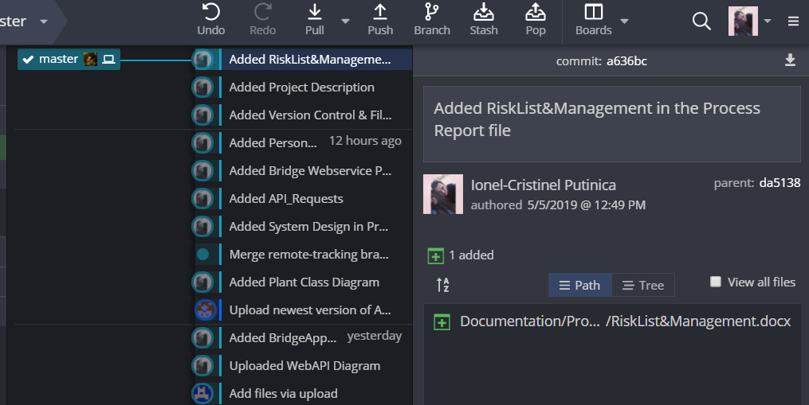

Figure Dashboard of the main repository in the early stages of the documentation

**File Sharing Management**

Different tools were used for sharing files between members of the group, the main one being Slack, a cloud-based software, based on team collaboration tools and services, where the team uploaded different parts of documentation, such as writing or diagrams. Other tools have also been used such as Dropbox and Google Drive, and, on a small scale Facebook as well.

**Communication and Planning**

As far as communication and planning went, the main tools that the team has made use of were Slack and Facebook, because of the ease that they offer regarding this services.

# Project Description

# Project Execution

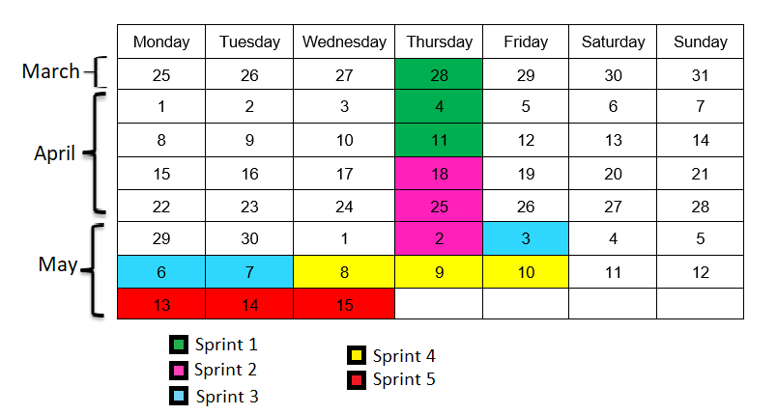

## Sprint 1

#### Sprint planning:

The first sprint started on the 28th of March and ended on the 11th of April. The sprint consisted of fourteen workdays, with 2 meetings per week.

The team started the work on the user interface of the app, as well as designing the system architecture.

Sprint backlog:

|  |  |  |  |
| --- | --- | --- | --- |
| **Task** | **Task category** | **Description** | **Responsible** |
| Create Login  and Register  Activities | System UI | Separate Activity class including XML | Angel Petrov, Ionel-Cristinel Putinica |
| Design system architecture concept | Documentation | Android system diagram | Angel Petrov, Erika Szasz, Ionel-Cristinel Putinica |
| Create main activity layout | System UI | Separate  Activity class  including XML | Erika Szasz |
| Create  fragment -  ModifyAccount | System UI | Used in  MainActivity, replaces  FrameLayout | Erika Szasz |
| Create  fragment - AddPlantFragment | System UI | Used in  MainActivity, replaces  FrameLayout | Erika Szasz |
| Create  LoginViewModel | System development | View<-  >Repository  communication | Angel Petrov |
| Create  RegisterViewModel | System development | View<-  >Repository  communication | Angel Petrov |
| IoT: Design System Architecture concept. |  |  | Christian, Diyar, Kenneth, Remedios. |
| IoT: Implement webservice socket connector. |  |  | Christian, Diyar, Kenneth, Remedios |
| Create database handler. |  |  | Christian, Diyar, Kenneth, Remedios. |
|  |  |  |  |

#### Sprint Review:

## Sprint 2

#### Sprint planning:

The second sprint started on the 18th of April until the 2nd of May and focus was on the system development.

#### Sprint Backlog:

|  |  |  |  |
| --- | --- | --- | --- |
| **Task** | **Task category** | **Description** | **Responsible** |
| Create DTO  objects | System  Development | Used in  RetrofitAPI for  performing  various data  in/out requests | Angel Petrov |
| Create  fragment –  ModifyPlantProfile | System UI | Used in  MainActivity  when clicked  on the pencil  icon | Angel Petrov, Erika Szasz |
| Style  Create/Modify  and ViewPlant  profiles | System UI | Added icons  and TextViews | Ionut-Cristinel Putinica |
| Create Plants &  User  Repositories | System development | Serve as a  “bridge” from  ViewModel to  remote data  gotten from  network | Angel Petrov |
| Create  RecyclerView in  MainActivity | System UI | Used in  MainActivity,  takes response from  ListAdapter | Angel Petrov |
| Create  ListAdapter | System development | Inflates  RecyclerView  with data in  MainActivity | Angel Petrov |
| Define  RetrofitAPI  requests | System development | Used for  navigating data  from and to the  remote WebAPI | Angel Petrov |
| IoT: Secure Server Socket. |  |  | Christian, Diyar, Kenneth, Remedios. |
| IoT: Implement Bridge Socket Protocol. |  |  | Christian, Diyar, Kenneth, Remedios. |
| IoT:  Connect bridge Application to real database. |  |  | Kenneth |
|  |  |  |  |
|  |  |  |  |

#### Sprint Review:

## Sprint 3

#### Sprint planning:

The third sprint started on the 3rd of May until the 7th of May.

#### Sprint backlog:

|  |  |  |  |
| --- | --- | --- | --- |
| **Task** | **Task category** | **Description** | **Responsible** |
| Create Login &  Register  Requests for  Networking | System  Development | Sends a  LoginDTO to  WebAPI and  gets a  response | Angel Petrov |
| Test Main Bridge Application. |  |  | Kenneth |
| Servomotor wiring |  |  | Christian, Diyar, Kenneth, Remedios. |
| Implement CO2 sensor |  |  | Christian, Diyar, Kenneth, Remedios. |
| Implement light sensor |  |  | Christian, Diyar, Kenneth, Remedios. |
|  |  |  |  |

#### Sprint Review:

## Sprint 4

#### Sprint planning:

The fourth sprint started on the 8th of May until the 10th of May.

#### Sprint backlog:

|  |  |  |  |
| --- | --- | --- | --- |
| **Task** | **Task category** | **Description** | **Responsible** |
| IoT: Connect LoRA and get HWEUI. |  |  | Christian, Diyar, Kenneth, Remedios. |
| IoT: Semaphore for the LoRA. |  |  | Kenneth, Remedios. |
| IoT: Set servomotor. |  |  | Christian, Kenneth |
| IoT: Connect the bridge application with the lora server. |  |  | Kenneth |
| IoT: Document Sprint. |  |  | Christian, Diyar, Remediosñ |
|  |  |  |  |

#### Sprint Review:

## Sprint 5

#### Sprint planning:

The fifth sprint started on the 13th of May until the 15th of May.

#### Sprint backlog:

|  |  |  |  |
| --- | --- | --- | --- |
| **Task** | **Task category** | **Description** | **Responsible** |
|  |  |  |  |
|  |  |  |  |
|  |  |  |  |

#### Sprint Review:

# Considerations after the project

**Ionut-Cristinel Putinica**

As an overall experience, for me, SEP4 was an important step for my engineering career. The most interesting experience was working in a group with this many members, and being split into sub-groups that work on different tiers of the application. Every single thing that I have worked on during this project has improved my knowledge, being it code implementation, testing, academic writing, working on diagrams, version control and time management. This project was also a re-assurance for me that it is way easier to work on something as being part of a group, rather than doing it by yourself, feedback and help being really valuable tools when working on a project, especially one of this scale.

**Erika Szasz**

I must admit that at first, I did not think an Internet of Things project will be very appealing to me, simply because I am more interested in other areas of Software Engineering. But having gone through the process of developing this project with my team, I must say it is was definitely a demanding experience that lead to a very interesting final product. There were some situations and tasks that thought me new skills and made me think outside of my usual pattern. Before the team was split in three subgroups, dealing with a team of 10 people, each with different ideas and visions, seemed a bit chaotic to me. But as we split, things became clearer and any conflicts dissipated. All in all, I feel I gained valuable experience from this both, both in terms of knowledge and human interaction.

# Conclusion